VISVESVARAYA TECHNOLOGICAL UNIVERSITY
JNANA SANGAMA, BELAGAVI - 590 018

SYSTEM SOFTWARE and COMPILER DESIGN ASSIGNMENT REPORT
on
“Flex & Bison for Windows”
Submitted by
Brijesh Vishwakarma 4SF24CS404
In partial fulfilment of the requirements for the VI Semester of

BACHELOR OF ENGINEERING
In
COMPUTER SCIENCE AND ENGINEERING



SAHYADRI
College of Engineering & Management
An Autonomous Institution
Adyar,Mangaluru - 575 007
2025- 26.

Program 1: Infix to Postfix Conversion

Lex Part (lexer.l)
%{
#include "parser.tab.h"
#include <string.h>
%}

%%
[0-9]+ { yylval.str = strdup(yytext); return NUMBER; }
[a-zA-Z_][a-zA-Z0-9_]* { yylval.str = strdup(yytext); return ID; }
[ \t\r]+ ;
\n { return '\n'; }
"+" { return '+'; }
"-" { return '-'; }
"*" { return '*'; }
"/" { return '/'; }
"(" { return '('; }
")" { return ')'; }
. { return yytext[0]; }
%%

int yywrap(void) {
return 1;
}

YACC Part (parser.y)
%{
#include <stdio.h>
#include <stdlib.h>
#include <string.h>

int yylex(void);
void yyerror(const char *s);

static char *make_postfix(const char *left, const char *right, const char *op) {
size_t len = strlen(left) + strlen(right) + strlen(op) + 3;
char *result = (char *)malloc(len);
snprintf(result, len, "%s %s %s", left, right, op);
return result;
}
%}

%union {
char *str;
}

%token <str> NUMBER ID
%type <str> expr term factor

%left '+' '-'
%left '*' '/'

%%
input:
expr '\n' { printf("Postfix: %s\n", $1); free($1); }
;
expr:
expr '+' term { $$ = make_postfix($1, $3, "+"); free($1); free($3); }
| expr '-' term { $$ = make_postfix($1, $3, "-"); free($1); free($3); }
| term { $$ = $1; }
;
term:
term '*' factor { $$ = make_postfix($1, $3, "*"); free($1); free($3); }
| term '/' factor { $$ = make_postfix($1, $3, "/"); free($1); free($3); }
| factor { $$ = $1; }
;
factor:
'(' expr ')' { $$ = $2; }
| NUMBER { $$ = $1; }
| ID { $$ = $1; }
;
%%
void yyerror(const char *s) {
fprintf(stderr, "Invalid expression: %s\n", s);
}
int main(void) {
printf("Brijesh Vishwakarma - 4SF24CS404\n");
printf("Enter infix expression: ");
yyparse();
return 0;
}

Output

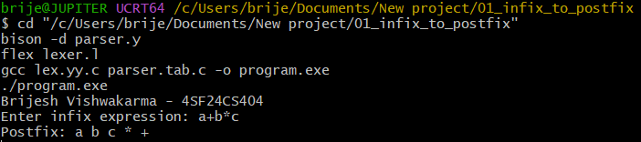

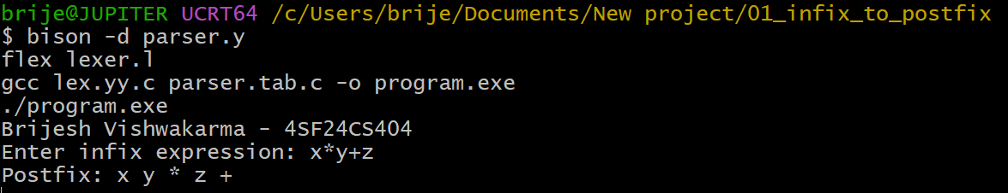

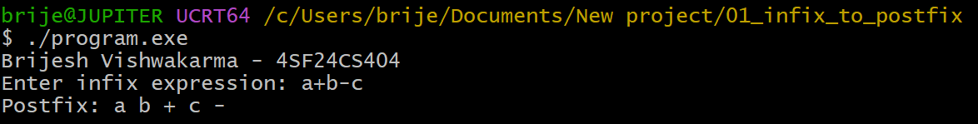

Program 2: Boolean Expression Evaluator

Lex Part (lexer.l)
%{
#include "parser.tab.h"
%}

%%
"&&" { return AND; }
"||" { return OR; }
"!" { return NOT; }
"true" { yylval.num = 1; return BOOL; }
"false" { yylval.num = 0; return BOOL; }
"1" { yylval.num = 1; return BOOL; }
"0" { yylval.num = 0; return BOOL; }
[ \t\r]+ ;
\n { return '\n'; }
"(" { return '('; }
")" { return ')'; }
. { return yytext[0]; }
%%

int yywrap(void) {
return 1;
}

YACC Part (parser.y)
%{
#include <stdio.h>

int yylex(void);
void yyerror(const char *s);
%}

%union {
int num;
}

%token <num> BOOL
%token AND OR NOT
%type <num> expr

%left OR
%left AND
%right NOT

%%
input:
expr '\n' { printf("Result: %s\n", $1 ? "true" : "false"); }
;
expr:
expr OR expr { $$ = $1 || $3; }
| expr AND expr { $$ = $1 && $3; }
| NOT expr { $$ = !$2; }
| '(' expr ')' { $$ = $2; }
| BOOL { $$ = $1; }
;
%%

void yyerror(const char *s) {
fprintf(stderr, "Invalid boolean expression: %s\n", s);
}

int main(void) {
printf("Brijesh Vishwakarma - 4SF24CS404\n");
printf("Enter boolean expression: ");
yyparse();
return 0;
}

Output

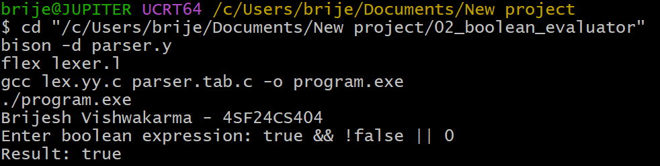

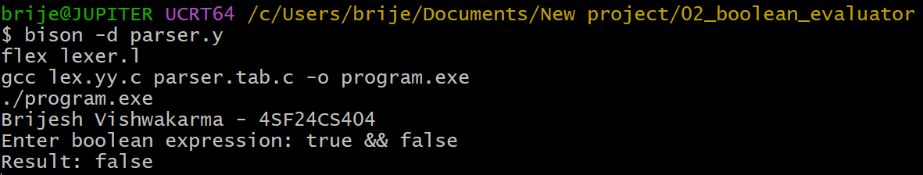

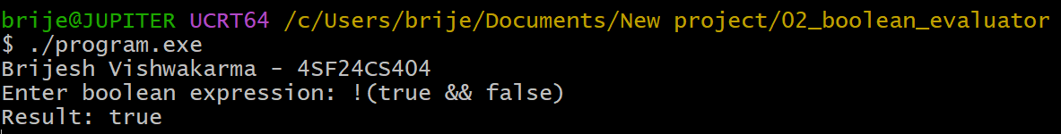

Program 3: Calculator with Variables

Lex Part (lexer.l)
%{
#include "parser.tab.h"
#include <stdlib.h>
#include <string.h>
%}

%%
[0-9]+ { yylval.num = atoi(yytext); return NUMBER; }
[a-zA-Z_][a-zA-Z0-9_]* { yylval.id = strdup(yytext); return ID; }
[ \t\r]+ ;
\n { return '\n'; }
"=" { return '='; }
"+" { return '+'; }
"-" { return '-'; }
"*" { return '*'; }
"/" { return '/'; }
"(" { return '('; }
")" { return ')'; }
. { return yytext[0]; }
%%

int yywrap(void) {
return 1;
}

YACC Part (parser.y)
%{
#include <stdio.h>
#include <stdlib.h>
#include <string.h>

int yylex(void);
void yyerror(const char *s);

typedef struct {
char name[64];
int value;
} Symbol;

static Symbol table[100];
static int symbol_count = 0;

static int lookup(const char *name, int *found) {
int i;
for (i = 0; i < symbol_count; i++) {
if (strcmp(table[i].name, name) == 0) {
*found = 1;
return table[i].value;
}
}
*found = 0;
return 0;
}

static void assign_value(const char *name, int value) {
int i;
for (i = 0; i < symbol_count; i++) {
if (strcmp(table[i].name, name) == 0) {
table[i].value = value;
return;
}
}

strcpy(table[symbol_count].name, name);
table[symbol_count].value = value;
symbol_count++;
}
%}

%union {
int num;
char *id;
}

%token <num> NUMBER
%token <id> ID
%type <num> expr term factor

%left '+' '-'
%left '*' '/'

%%
input:
/* empty */
| input line
;

line:
ID '=' expr '\n'
{
assign_value($1, $3);
printf("%s = %d\n", $1, $3);
free($1);
}
| expr '\n'
{
printf("Result = %d\n", $1);
}
| '\n'
;

expr:
expr '+' term { $$ = $1 + $3; }
| expr '-' term { $$ = $1 - $3; }
| term { $$ = $1; }
;

term:
term '*' factor { $$ = $1 * $3; }
| term '/' factor
{
if ($3 == 0) {
yyerror("division by zero");
$$ = 0;
} else {
$$ = $1 / $3;
}
}
| factor { $$ = $1; }
;

factor:
'(' expr ')' { $$ = $2; }
| NUMBER { $$ = $1; }
| ID
{
int found;
$$ = lookup($1, &found);
if (!found) {
fprintf(stderr, "Undefined variable: %s\n", $1);
$$ = 0;
}
free($1);
}
;
%%

void yyerror(const char *s) {
fprintf(stderr, "Error: %s\n", s);
}

int main(void) {
printf("Brijesh Vishwakarma - 4SF24CS404\n");
printf("Enter assignments or expressions (Ctrl+D/Ctrl+Z to stop):\n");
yyparse();
return 0;
}

Output

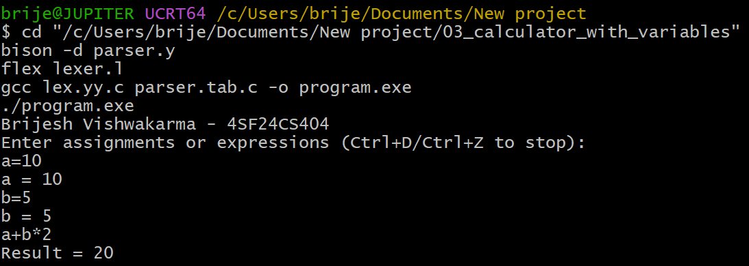

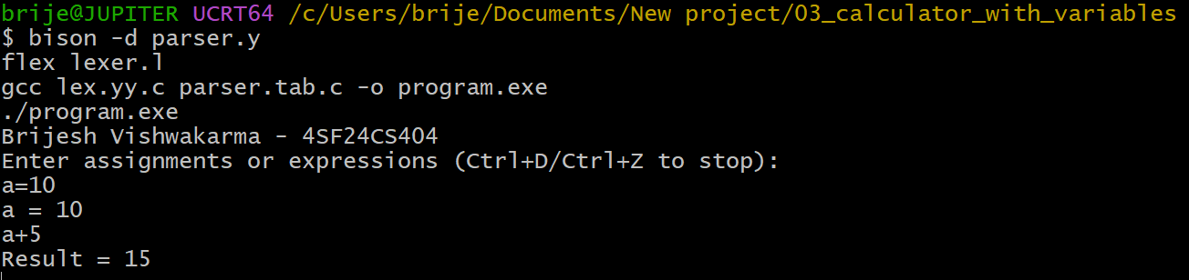

Program 4: For Loop Syntax Validator

Lex Part (lexer.l)
%{
#include "parser.tab.h"
#include <stdlib.h>
#include <string.h>
%}

%%
"for" { return FOR; }
"++" { return INC; }
"--" { return DEC; }
"=="|"<="|">="|"!="|"<"|">" { return RELOP; }
[0-9]+ { yylval.num = atoi(yytext); return NUMBER; }
[a-zA-Z_][a-zA-Z0-9_]* { yylval.id = strdup(yytext); return ID; }
[ \t\r\n]+ ;
"=" { return ASSIGN; }
";" { return ';'; }
"(" { return '('; }
")" { return ')'; }
"{" { return '{'; }
"}" { return '}'; }
"+" { return '+'; }
"-" { return '-'; }
"*" { return '*'; }
"/" { return '/'; }
. { return yytext[0]; }
%%

int yywrap(void) {
return 1;
}

YACC Part (parser.y)
%{
#include <stdio.h>
#include <stdlib.h>

int yylex(void);
void yyerror(const char *s);
%}

%union {
int num;
char *id;
}

%token FOR INC DEC RELOP ASSIGN
%token <num> NUMBER
%token <id> ID

%left '+' '-'
%left '*' '/'

%%
input:
for_stmt { printf("Valid for loop syntax\n"); }
;

for_stmt:
FOR '(' opt_expr ';' opt_cond ';' opt_expr ')' body
;

opt_expr:
/* empty */
| assignment
| update
| expr
;

opt_cond:
/* empty */
| condition
;

assignment:
ID ASSIGN expr { free($1); }
;

update:
ID INC { free($1); }
| ID DEC { free($1); }
| INC ID { free($2); }
| DEC ID { free($2); }
| assignment
;

condition:
expr RELOP expr
;

body:
statement ';'
| block
;

statement:
assignment
| update
;

block:
'{' stmt_list '}'
;

stmt_list:
/* empty */
| stmt_list statement ';'
;

expr:
expr '+' expr
| expr '-' expr
| expr '*' expr
| expr '/' expr
| '(' expr ')'
| ID { free($1); }
| NUMBER
;
%%

void yyerror(const char *s) {
fprintf(stderr, "Invalid for loop syntax: %s\n", s);
}

int main(void) {
printf("Brijesh Vishwakarma - 4SF24CS404\n");
printf("Enter a for loop statement:\n");
yyparse();
return 0;
}

Output

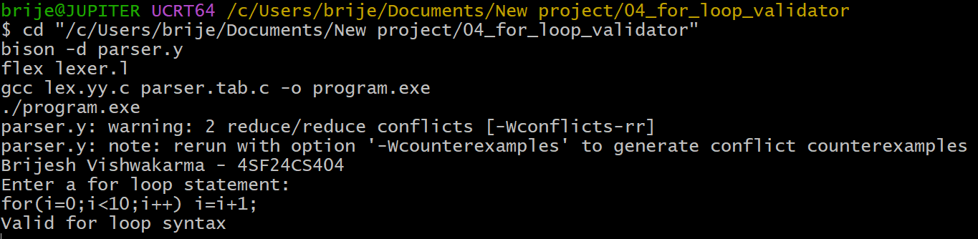

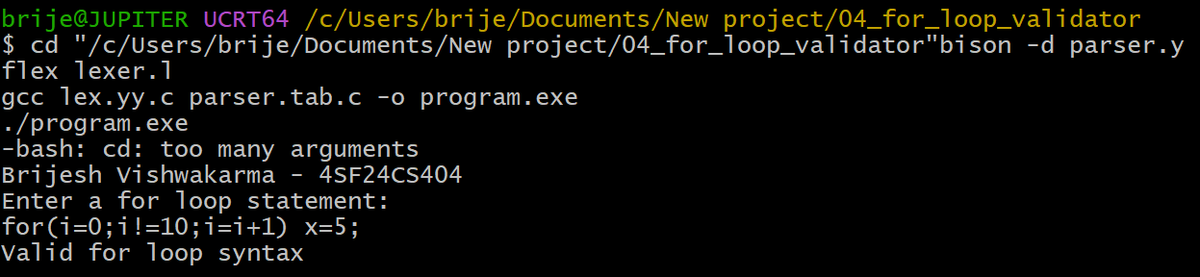

Program 5: Balanced Parentheses Checker

Lex Part (lexer.l)
%{
#include "parser.tab.h"
%}
%%
"(" { return LPAREN; }
")" { return RPAREN; }
\n { return '\n'; }
. { return OTHER; }
%%
int yywrap(void) {
return 1;
}

YACC Part (parser.y)
%{
#include <stdio.h>

int yylex(void);
void yyerror(const char *s);
%}

%token LPAREN RPAREN OTHER

%%
input:
sequence '\n' { printf("Parentheses are balanced\n"); }
;
sequence:
/* empty */
| sequence element
;
element:
OTHER
| LPAREN sequence RPAREN
;
%%
void yyerror(const char *s) {
fprintf(stderr, "Parentheses are not balanced\n");
}
int main(void) {
printf("Brijesh Vishwakarma - 4SF24CS404\n");
printf("Enter a string: ");
yyparse();
return 0;
}

Output

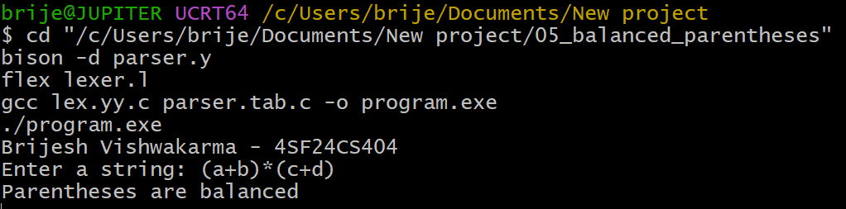

Program 6: Variable Declaration Validator

Lex Part (lexer.l)
%{
#include "parser.tab.h"
#include <string.h>
%}
%%
"int"|"float"|"char"|"double" { return TYPE; }
[a-zA-Z_][a-zA-Z0-9_]* { yylval.id = strdup(yytext); return ID; }
[ \t\r\n]+ ;
"," { return ','; }
";" { return ';'; }
. { return yytext[0]; }
%%
int yywrap(void) {
return 1;}

YACC Part (parser.y)
%{
#include <stdio.h>
#include <stdlib.h>
int yylex(void);
void yyerror(const char *s);
%}
%union {
char *id;
}
%token TYPE
%token <id> ID
%%
input:
declaration { printf("Valid variable declaration\n"); }
;declaration:
TYPE id_list ';'
;
id_list:
ID { free($1); }
| id_list ',' ID { free($3); }
;
%%
void yyerror(const char *s) {
fprintf(stderr, "Invalid declaration: %s\n", s);
}
int main(void) {
printf("Brijesh Vishwakarma - 4SF24CS404\n");
printf("Enter a declaration statement:\n");
yyparse();
return 0;
}

Output
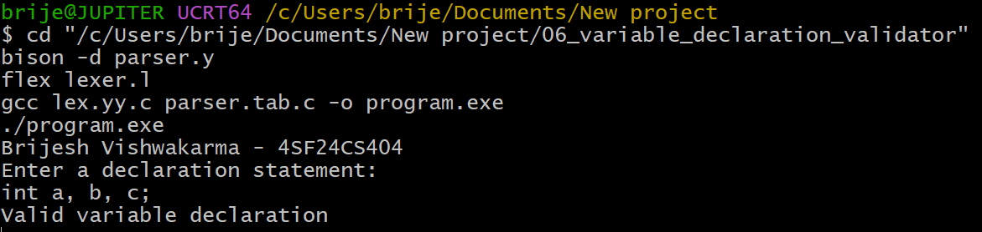

Program 7: If-Else Syntax Validator

Lex Part (lexer.l)
%{
#include "parser.tab.h"
#include <stdlib.h>
#include <string.h>
%}

%%
"if" { return IF; }
"else" { return ELSE; }
"=="|"<="|">="|"!="|"<"|">" { return RELOP; }
[0-9]+ { yylval.num = atoi(yytext); return NUMBER; }
[a-zA-Z_][a-zA-Z0-9_]* { yylval.id = strdup(yytext); return ID; }
[ \t\r\n]+ ;
"=" { return ASSIGN; }
";" { return ';'; }
"(" { return '('; }
")" { return ')'; }
"{" { return '{'; }
"}" { return '}'; }
"+" { return '+'; }
"-" { return '-'; }
"*" { return '*'; }
"/" { return '/'; }
. { return yytext[0]; }
%%

int yywrap(void) {
return 1;
}

YACC Part (parser.y)
%{
#include <stdio.h>
#include <stdlib.h>

int yylex(void);
void yyerror(const char *s);
%}

%union {
int num;
char *id;
}

%token IF ELSE RELOP ASSIGN
%token <num> NUMBER
%token <id> ID

%nonassoc LOWER_THAN_ELSE
%nonassoc ELSE

%left '+' '-'
%left '*' '/'

%%
input:
stmt { printf("Valid if-else syntax\n"); }
;
stmt:
IF '(' condition ')' stmt %prec LOWER_THAN_ELSE
| IF '(' condition ')' stmt ELSE stmt
| simple_stmt ';'
| block
;
block:
'{' stmt_list '}'
;

stmt_list:
/* empty */
| stmt_list stmt
;

simple_stmt:
ID ASSIGN expr { free($1); }
;

condition:
expr RELOP expr
;
expr:
expr '+' expr
| expr '-' expr
| expr '*' expr
| expr '/' expr
| '(' expr ')'
| ID { free($1); }
| NUMBER
;
%%
void yyerror(const char *s) {
fprintf(stderr, "Invalid if-else syntax: %s\n", s);
}
int main(void) {
printf("Brijesh Vishwakarma - 4SF24CS404\n");
printf("Enter an if-else statement:\n");
yyparse();
return 0;
}

Output

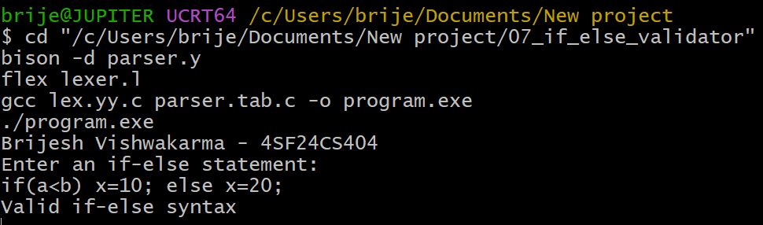

Program 8: Simple Type Checker

Lex Part (lexer.l)
%{
#include "parser.tab.h"
#include <stdlib.h>
#include <string.h>
%}

%%
"int" { return INT; }
"float" { return FLOAT; }
[0-9]+"."[0-9]+ { yylval.fval = (float)atof(yytext); return FVAL; }
[0-9]+ { yylval.ival = atoi(yytext); return IVAL; }
[a-zA-Z_][a-zA-Z0-9_]* { yylval.id = strdup(yytext); return ID; }
[ \t\r]+ ;
\n { return '\n'; }
"=" { return '='; }
";" { return ';'; }
"+" { return '+'; }
"-" { return '-'; }
"*" { return '*'; }
"/" { return '/'; }
"(" { return '('; }
")" { return ')'; }
. { return yytext[0]; }
%%

int yywrap(void) {
return 1;
}

YACC Part (parser.y)
%{
#include <stdio.h>
#include <stdlib.h>
#include <string.h>

int yylex(void);
void yyerror(const char *s);

enum {
TYPE_INT = 1,
TYPE_FLOAT = 2,
TYPE_ERROR = -1
};

typedef struct {
char name[64];
int type;
} Symbol;

static Symbol table[100];
static int symbol_count = 0;

static void declare_symbol(const char *name, int type) {
int i;
for (i = 0; i < symbol_count; i++) {
if (strcmp(table[i].name, name) == 0) {
table[i].type = type;
return;
}
}
strcpy(table[symbol_count].name, name);
table[symbol_count].type = type;
symbol_count++;
}

static int get_symbol_type(const char *name) {
int i;
for (i = 0; i < symbol_count; i++) {
if (strcmp(table[i].name, name) == 0) {
return table[i].type;
}
}
return TYPE_ERROR;
}

static int compatible(int lhs, int rhs) {
if (lhs == TYPE_FLOAT && (rhs == TYPE_FLOAT || rhs == TYPE_INT)) {
return 1;
}
if (lhs == TYPE_INT && rhs == TYPE_INT) {
return 1;
}
return 0;
}

static int promote(int a, int b) {
if (a == TYPE_ERROR || b == TYPE_ERROR) {
return TYPE_ERROR;
}
if (a == TYPE_FLOAT || b == TYPE_FLOAT) {
return TYPE_FLOAT;
}
return TYPE_INT;
}
%}

%union {
int type;
int ival;
float fval;
char *id;
}

%token INT FLOAT
%token <ival> IVAL
%token <fval> FVAL
%token <id> ID
%type <type> type_spec expr term factor

%left '+' '-'
%left '*' '/'

%%
input:
/* empty */
| input line
;

line:
declaration '\n'
| assignment '\n'
| '\n'
;

declaration:
type_spec ID ';'
{
declare_symbol($2, $1);
printf("Declared %s as %s\n", $2, $1 == TYPE_INT ? "int" : "float");
free($2);
}
;

assignment:
ID '=' expr ';'
{
int lhs = get_symbol_type($1);
if (lhs == TYPE_ERROR) {
fprintf(stderr, "Undeclared variable: %s\n", $1);
} else if (!compatible(lhs, $3)) {
fprintf(stderr, "Type error: cannot assign float value to int variable %s\n", $1);
} else {
printf("Type check success for %s\n", $1);
}
free($1);
}
;

type_spec:
INT { $$ = TYPE_INT; }
| FLOAT { $$ = TYPE_FLOAT; }
;

expr:
expr '+' term { $$ = promote($1, $3); }
| expr '-' term { $$ = promote($1, $3); }
| term { $$ = $1; }
;

term:
term '*' factor { $$ = promote($1, $3); }
| term '/' factor { $$ = promote($1, $3); }
| factor { $$ = $1; }
;

factor:
'(' expr ')' { $$ = $2; }
| IVAL { $$ = TYPE_INT; }
| FVAL { $$ = TYPE_FLOAT; }
| ID
{
$$ = get_symbol_type($1);
if ($$ == TYPE_ERROR) {
fprintf(stderr, "Undeclared variable: %s\n", $1);
}
free($1);
}
;
%%

void yyerror(const char *s) {
fprintf(stderr, "Syntax error: %s\n", s);
}

int main(void) {
printf("Brijesh Vishwakarma - 4SF24CS404\n");
printf("Enter declarations and assignments:\n");
yyparse();
return 0;
}

Output

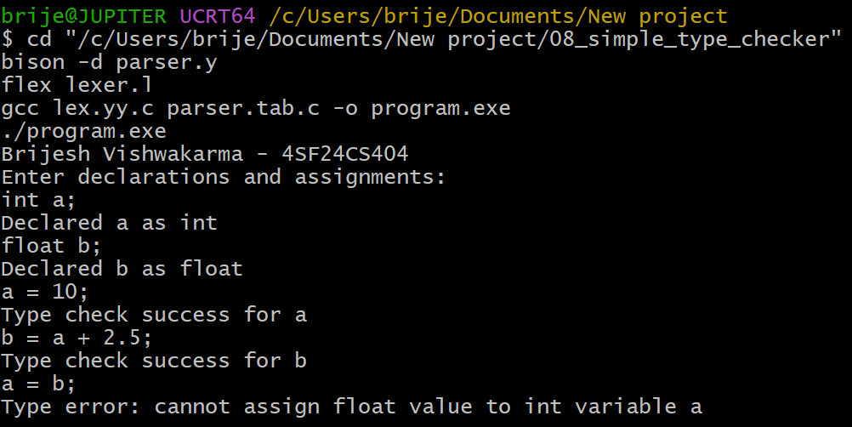

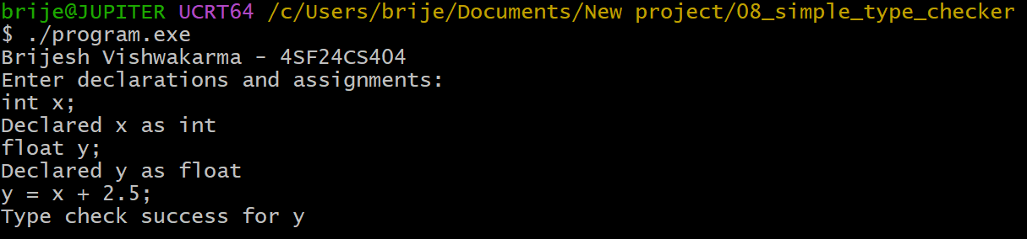

Program 9: Relational Expression Validator

Lex Part (lexer.l)
%{
#include "parser.tab.h"
#include <stdlib.h>
#include <string.h>
%}

%%
"=="|"<="|">="|"!="|"<"|">" { return RELOP; }
[0-9]+ { yylval.num = atoi(yytext); return NUMBER; }
[a-zA-Z_][a-zA-Z0-9_]* { yylval.id = strdup(yytext); return ID; }
[ \t\r\n]+ ;
"+" { return '+'; }
"-" { return '-'; }
"*" { return '*'; }
"/" { return '/'; }
"(" { return '('; }
")" { return ')'; }
. { return yytext[0]; }
%%

int yywrap(void) {
return 1;
}

YACC Part (parser.y)
%{
#include <stdio.h>
#include <stdlib.h>

int yylex(void);
void yyerror(const char *s);
%}

%union {
int num;
char *id;
}

%token RELOP
%token <num> NUMBER
%token <id> ID

%left '+' '-'
%left '*' '/'

%%
input:
relation { printf("Valid relational expression\n"); }
;

relation:
expr RELOP expr
;

expr:
expr '+' expr
| expr '-' expr
| expr '*' expr
| expr '/' expr
| '(' expr ')'
| ID { free($1); }
| NUMBER
;
%%

void yyerror(const char *s) {
fprintf(stderr, "Invalid relational expression: %s\n", s);
}

int main(void) {
printf("Brijesh Vishwakarma - 4SF24CS404\n");
printf("Enter a relational expression:\n");
yyparse();
return 0;
}

Output
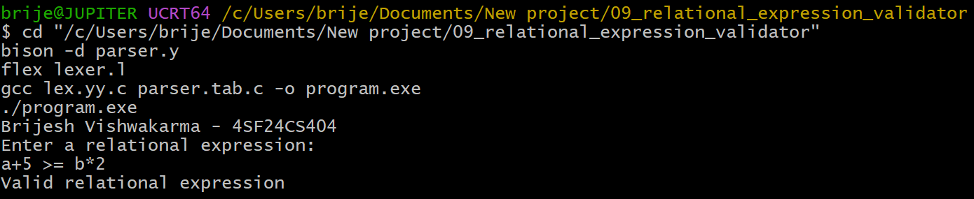

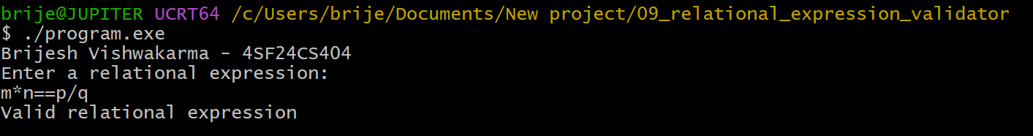

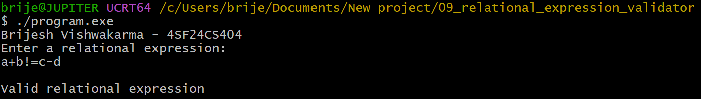

Program 10: Arithmetic Evaluator

Lex Part (lexer.l)
%{
#include "parser.tab.h"
#include <stdlib.h>
%}

%%
[0-9]+ { yylval.num = atoi(yytext); return NUMBER; }
[ \t\r]+ ;
\n { return '\n'; }
"+" { return '+'; }
"-" { return '-'; }
"*" { return '*'; }
"/" { return '/'; }
"(" { return '('; }
")" { return ')'; }
. { return yytext[0]; }
%%

int yywrap(void) {
return 1;
}

YACC Part (parser.y)
%{
#include <stdio.h>

int yylex(void);
void yyerror(const char *s);
%}

%union {
int num;
}

%token <num> NUMBER
%type <num> expr term factor

%left '+' '-'
%left '*' '/'

%%
input:
expr '\n' { printf("Result = %d\n", $1); }
;

expr:
expr '+' term { $$ = $1 + $3; }
| expr '-' term { $$ = $1 - $3; }
| term { $$ = $1; }
;

term:
term '*' factor { $$ = $1 * $3; }
| term '/' factor
{
if ($3 == 0) {
yyerror("division by zero");
$$ = 0;
} else {
$$ = $1 / $3;
}
}
| factor { $$ = $1; }
;

factor:
'(' expr ')' { $$ = $2; }
| NUMBER { $$ = $1; }
;
%%

void yyerror(const char *s) {
fprintf(stderr, "Invalid arithmetic expression: %s\n", s);
}

int main(void) {
printf("Brijesh Vishwakarma - 4SF24CS404\n");
printf("Enter arithmetic expression: ");
yyparse();
return 0;
}

Output

